Contents

Checklists
Performance Checklist
Deadlock Checklist
Hang Checklist
Explanations
Intro - Characterization of database problems
Hang Diagnosis
Deadlock Diagnosis
Performance Diagnosis
Appendix A - Documentum troubleshooting steps
DMCL Trace
SQL Trace
Stack dump of OS Process
System call tracing
Network tracing
Appendix B - Database troubleshooting steps
Microsoft SQL Server
DB2 Diagnostics
Sybase Diagnostics
MySQL Diagnostics
Oracle Miscellaneous
Locks Held
Current Queries
Deadlock tracing
Queryplans

Performance Checklist | Top Next

Obtain DQL and SQL queries being run
Obtain query plans for the SQL queries
Obtain list of tables involved
List of Indexes on each table involved
Number of rows in each table involved.
Cardinality of tables - are the rows unique - how unique?
When did statistics last get updated?
Find out if the query is slow in isolation, or only in a loaded environment

Sybase/SQL Server
http://supportability.documentum.com/rs- bin/RightSite.dll/getcontent/098babbb8002e995?DMW_OBJECTID=098babbb8002e995

Oracle
http://supportability.documentum.com/rs- bin/RightSite.dll/getcontent/098babbb8002e98b?DMW_OBJECTID=098babbb8002e98b

Oracle Performance script - See SN 74664

Deadlock Checklist | Previous Top Next
You need

1.) List of resources in a locking cycle
2.) SQL Trace of the events leading to the deadlock
3.) For the queries involved in the deadlock, the query plans

For obtaining #1

SQL Server and Sybase

dbcc traceon (1204, 1205, 3605)

DB2

create an event trigger

Oracle

look in alert.log

Hang Checklist | Previous Top Next
1.) Is this hang repeatable – what operation causes the hang?
2.) Obtain Process Stack Dump of the process(es) as they are hanging. If on Unix - this is for every content server process.
3.) Obtain SQL Trace of operation as it occurs. The trace must be started before the hang takes place.
4.) Obtain a list of database locks
5.) Is there any custom code involved?
6.) Database type and version?
7.) Are there any lock timeouts?
8.) Database configurations (lock escalation parameters?)
9.) Query plans of query that is hung.

Characterization of database problems | Previous Top Next
The problems we (as support) have seen in the database layer are generally classed in 2 types:
• Hangs or deadlocks
• Performance

Now before even getting to this stage - we need be able to determine if a problem exists in the database layer.

Is the problem in the database layer?

This itself is a large topic - so here are some pointers:

Performance problems
- Do a DMCL trace. Note that in a DMCL trace, even things that do not look like queries can be queries. For example, "fetch" does not look like a query, neither does "create and save", but both send queries to the database.
- Do a SQL trace (either from the database or from the content server) - see how much time is spent in query execution. This will give a clear indication.

Hangs (Deadlocks not resolved by the database)
- If an application hangs, then get a stack dump of the process on either Unix or Windows. When you examine the stack, you can see if multiple threads/processes have functions pointing into the native database layer (ie you see OCI/ODBC/CLI functions in the call stack). This is not conclusive evidence that a particular thread or process is hanging in the database (unless you take successive snapshots and the particular thread/process remains in the same state).

Another way to diagnose hangs is to examine the process state at the database level. What this means is that you want to see what are the current queries running in the database (issued from your application), along with the locks held by your application.

Deadlocks resolved by the database

You need to get an SQL trace along with some database tracing to print out
information for deadlocks.

Why are some deadlocks resolved by the database, whereas others remain - causing a hang?

Hang and deadlock are used to describe specific situations - and the steps needed to resolve them differ. Both are technically deadlocks, a cyclic dependency of resources.

The database hang refers to a situation in which a conflict of database resources cannot be resolved by the database. The symptom of a database hang is that a database connection will not respond - the query results will never be returned. Sometimes this is caused by a client-server resource dependency, and sometimes this can be caused by an application coding bug. For example, someone may forget to commit a transaction.

A deadlock which is automatically resolved is conflict of database resources which can be detected by the database itself, and the database will resolve this conflict by killing one of the connections involved in the resource conflict - generally the connection which has done the least work. One of the connections involved in a database deadlock will receive a message from the database saying that its work/query was terminated.

A deadlock can be resolved if the resources in the cycle are purely in the database, whereas the hang (also a form of deadlock) involves non-database resources. The database cannot detect the deadlock cycle and thus cannot break it.

API Server code which causes a deadlock
resolved by the database

connect,docbase1,user1,pwd1 <= returns s1
connect,docbase1,user1,pwd1 <= returns s2
create,s1,dm_document
save,s1,l
create,s2,dm_folder
save,s1,l
create,s1,dm_folder
save,s1,l
create,s2,dm_document
save,s1,l <= hang occurs here

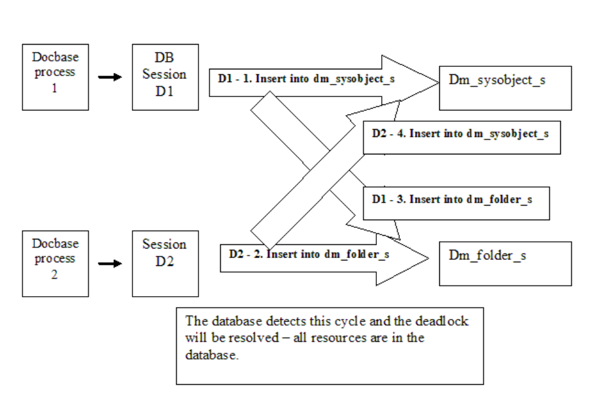

Code that causes a hang - imagine this is server code.

// d1 and d2 are connections to the database
CreateTwoObjects()
{
// create sysobject1 using a particular database connection
CreateSysobject(d1);
CreateFolder(d2);
CreateSysobject(d1); <= hang here
// because we are in code and can't go backwards
// notice the cycle is not because of another folder creation.
return true;
}

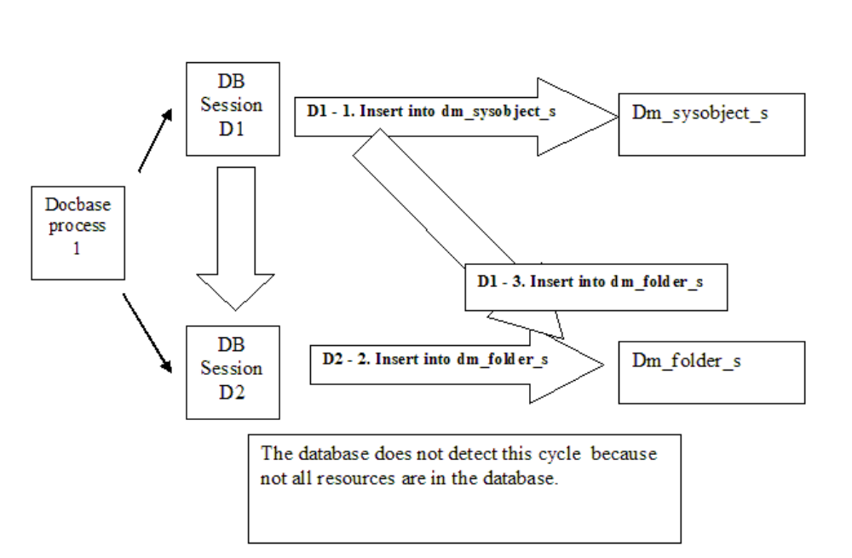

Database Resources - Locks

In the example above, the database resource is really a lock.
Locks protect resources - the are a pessimistic synchronization mechanism.
The implementation varies among databases and a database
reference manual will have full details.

Lock Granularity
In general, locks can be held on databases, tables or indexes - either the whole thing, or parts of it. For example, a table consists of pages, and a page consists
of rows - and locks can be held at both levels.

Lock Type
Locks can generally either be read or write where reader locks
are shared locks and writer locks are exclusive. This means that
if someone is reading, then others can read, but no-one can write.
If someone is writing, no-one will be able to read or write.

Details about Locking

Database vendors have gone through extensive research on locking to reduce conflicts. There are different types of write locks (Update, Delete, Schema locks).
Oracle, SQL Server 2005 and MySQL have different write blocking behavior than
Sybase, SQL Server 2000, and DB2. Writers will not block readers. Lock escalation can occur which can increase contention but reduce memory usage.

SQL Server 2005 Lock Compatibility.

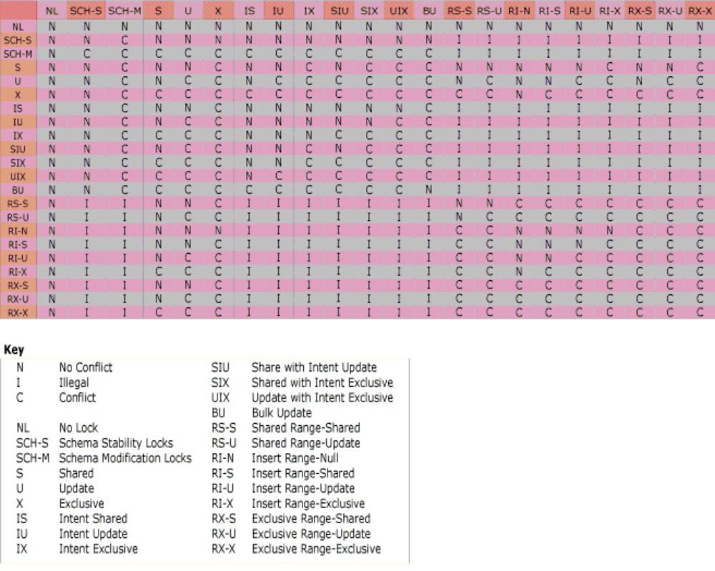

Oracle 10g Lock Compatibility (from Oracle documentation)
Table 13-3 Summary of Table Locks
SQL Statement | Mode of Table Lock | Lock Modes Permitted?
SQL Statement | Mode of Table Lock | RS |  | RX | S | SRX | X
SELECT...FROM table... | none | Y |  | Y | Y | Y | Y
INSERT INTO table ... | RX | Y |  | Y | N | N | N
UPDATE table ... | RX | Y* |  | Y* | N | N | N
DELETE FROM table ... | RX | Y* |  | Y* | N | N | N
SELECT ... FROM table FOR UPDATE OF ... | RS | Y* |  | Y* | Y* | Y* | N
LOCK TABLE table IN ROW SHARE MODE | RS | Y |  | Y | Y | Y | N
LOCK TABLE table IN ROW EXCLUSIVE MODE | RX | Y |  | Y | N | N | N
LOCK TABLE table IN SHARE MODE | S | Y |  | N | Y | N | N
LOCK TABLE table IN SHARE ROW EXCLUSIVE MODE | SRX | Y |  | N | N | N | N
LOCK TABLE table IN EXCLUSIVE MODE | X | N |  | N | N | N | N
RS: row share
RX: row exclusive
S: share
SRX: share row exclusive
X: exclusive
*Yes, if no conflicting row locks are held by another transaction. Otherwise, waits occur.

Hang Diagnosis | Previous Top Next
Hangs

By this point, you should have verified that the hang is indeed related to the database - see the Introduction.

You need determine what database connection is performing what action so that you can correlate code to SQL Statements.

Generally, Documentum hangs caused by the content server have intermingled use of Temp and User database connections. Customer caused hangs are generally by code that is improperly written.

Diagnosis of data to be gathered from the hang checklist.

Draw a picture of the deadlock diagram
Determine where the responsibility of releasing resources lies - if the Content Server is issuing queries in a transaction it created itself, then the responsibility will be with the Content Server. If the client-side has requested a transaction - then the problem may be in the client.

Check if the server session which is hanging is blocking itself.

Run a SHOW_SESSIONS apply method (or view the sessions from DA). Check the db_id field
and see if the database sessions which you see blocking each other are from the same content server process.

SQL statement trace
A list of locks held and being waited for by each database session.

1.) If we know what causes the problem in the code, this makes the task of fixing the code much easier.
- Does this error occur with a single user or with multiple users?
- Does this occur with workflow/data dictionary/alter type, etc..?
- Are there any jobs running at the same time?
- Certain time of day when the hang occurs
- In the suspect code, is there a mix of temp and user connections?

2.) The SQL statement trace helps narrow down where in the code an operation is occurring.
Fetch | SELECT * FROM dmi_dd_type_info_rv QF_ , dmi_dd_type_info_sv PF_ WHERE (PF_.r_object_id=@P1 AND PF_.r_object_id=QF_.r_object_id) ORDER BY QF_.r_object_id,QF_.i_position', N'@P1 nvarchar(36)', N'690086e780000d24' | A fetch is a select * from the join of sv and rv, ordered by i_position
object is up to date | SELECT SB_.r_object_id FROM dm_sysobject_s SB_ WHERE (SB_.r_object_id=@P1 AND SB_.i_vstamp=@P2 ) | We select r_object_id based on r_object_id and i_vstamp
Save of New object | INSERT INTO dm_document_s VALUES(N'090086e780001a4a')  INSERT INTO dm_sysobject_s VALUES(N'090086e780001a4a',N' ',N'dm_document',N' ',N' ',N' ',N' ',N'2004-05-17 23:09:54.000',N'2004-05-17 23:09:54.000',N'nagboat',N'1753-01-01 00:00:00.000', 0, 0,N'1753-01-01 00:00:00.000', 0,N' ', 0, 1, 1, 0, 0,N'0000000000000000', 0, 0,N' ', 0,N'0000000000000000',N' ', 0, 0, 1,N'filestore_01',N'0c0086e780000104',N'nagboat', 7,N'docu', 5, 3,N'0000000000000000',N'090086e780001a4a', 1,N' ',N'1753-01-01 00:00:00.000',N' ',N' ', 0, 0, 0, 0, 0,N'nagboat',N'dm_450086e780000102',N' ', 0,N'nagboat', 1,N'0000000000000000', 0, 0,N'0000000000000000',N' ',N' ', 0,N' ',0.000000000000000, 0,N'1753-01-01 00:00:00.000', 0, 0)  INSERT INTO dm_sysobject_r VALUES(N'090086e780001a4a',-1, NULL, NULL,N'0c0086e780000104', NULL, NULL, NULL, NULL,N'1.0', NULL, NULL, NULL, NULL, NULL, NULL)  INSERT INTO dm_sysobject_r VALUES(N'090086e780001a4a',-2, NULL, NULL, NULL, NULL, NULL, NULL, NULL,N'CURRENT', NULL, NULL, NULL, NULL, NULL, NULL)  INSERT INTO dmi_object_type VALUES(N'090086e780001a4a',-2147483351) | This consist of inserting into the type table of the object and its supertypes along with an insert into dmi_object_type.
Save of Existing Object | UPDATE dm_sysobject_s SET object_name=N''temp'',r_modify_date=N''2004-05-17 23:18:37.000'',r_modifier=N''nagboat'',r_lock_owner=N'' '',r_lock_date=N''1753-01-01 00:00:00.000'',r_lock_machine=N'' '',i_vstamp= 2 WHERE (r_object_id=@P1 AND i_vstamp=@P2 )', N'@P1 nvarchar(36),@P2 int', N'090086e780001a4a', 1 | This is an update to an existing row – if the attribute was repeating, in this case both _s and _r  tables would have been modified.
Destroy of Object | select r_object_id from dm_relation_s where (child_id = @P1 or parent_id = @P2 )', @P2 output, @P3 ou  SELECT BYI_.i_type FROM dmi_object_type BYI_ WHERE BYI_.r_object_id=@P1 ', N'@P1 nvarchar(36)', N'090086e780001a4a'  DELETE FROM dm_document_s WHERE r_object_id=@P1 ', N'@P1 nvarchar(36)', N'090086e780001a4a'  DELETE FROM dm_sysobject_s WHERE (r_object_id=@P1 AND i_vstamp=@P2 )', N'@P1 nvarchar(36),@P2 int', N'090086e780001a4a', 2  DELETE FROM dm_sysobject_r WHERE r_object_id=@P1 ', N'@P1 nvarchar(36)', N'090086e780001a4a'  DELETE FROM dmi_object_type WHERE r_object_id=@P1 ', N'@P1 nvarchar(36)', N'090086e780001a4a' | The basic delete of an object will delete database rows from the type tables and dmi_object_type  In sysobjects case, we also check relations.
determine the type of an object | SELECT UXI_.i_type FROM dmi_object_type UXI_ WHERE UXI_.r_object_id=@P1 ', N'@P1 nvarchar(36)', N'0c0086e780000104' | This means that – we look in dmi_object_type to determine which table to fetch from – based on the i_type value, the next statement will probably fetch based on the i_type result
commit on SQL Server/Sybase | IF @@TRANCOUNT > 0 COMMIT TRAN | Oracle will not have commits.
Logon for SQL Server/Sybase | set implicit_transactions on  USE DM_win52_docbase
workflow agent (5.2) | select all r_object_id, r_workflow_id from dmi_workitem_s WITH ( READPAST ) where r_runtime_state in (0,1) and r_auto_method_id > '0000000000000000' and r_exec_launch = 0 order by r_priority desc, r_creation_date desc | Since this runs frequently, this can be filtered out if irrelevant.

One thing to be aware of is on which connection does each operation occur? Does the save occur on 1 connection and the fetch on the other connection?

http://softwaresupport.emc.com/support/resolutions/dmfrmresolutionview.asp?id=2198
SN 2198
An example from SQL Server 2000

The lock chain is like this

Deadlock Diagnosis | Previous Top Next

When you get a deadlock, the documentum server will return to the DMCL
client the message DEADLOCK
TRANSACTION ABORTED.

The expectation is that these deadlocks happen randomly. You need to determine the high level operations and how they correspond to the database resources.

What queries are involved and what is the deadlock chain. For example, bug 73979.
We had a situation where 2 queries were being run on dm_workitem_s , one was a

ri Feb 27 12:13:34 2004 360000 [DM_WORKFLOW_E_CURSOR]error: "The cursor 'select all r_object_id, r_workflow_id from dmi_workitem_s WITH ( READPAST ) where r_runtime_state in (0,1) and r_auto_method_id > '0000000000000000' and r_exec_launch = 0 order by r_priority desc, r_creation_date desc ' fails.
The error message from the database server is: -- Deadlock error -- STATE=40001, CODE=1205, MSG=[Microsoft][ODBC SQL Server Driver][SQL Server]Transaction (Process ID 53) was deadlocked on lock resources with another process and has been chosen as the deadlock victim. Rerun the transaction. ."

and the other was an UPDATE , or INSERT.
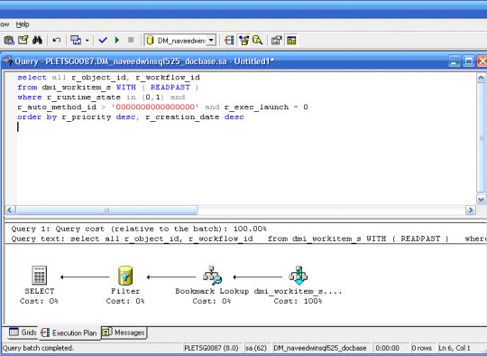

the Select was accessing index 048, but this was not a covering index (r_workflow_id was not in the index).

The select would access the index, and then do a bookmark lookup on the base table. But in the meantime, an insert or update had locked the base table, and was going to update the 048 index.

This caused a SQL Server deadlock - the solution is to make 048 a covering index, so the select does not access 2 database objects (index and table)
http://support.microsoft.com/?kbid=832524
excellent article titled How to resolve a deadlock

read Ed Bueche’s paper “Documentum Application Performance and Tuning “
The latest version I have seen is version 2, May 3, 2003

Performance Diagnosis | Previous Top Next
Some important questions:
Is the query from Documentum, or from the customer?
What is the query trying to achieve – in an English sentence?

For example

select distinct i_supergroups from dm_group_r gr1 , dm_group_r gr2
where gr1.r_object_id = gr2.r_object_id and gr2.users_names='agboan' and gr1.i_supergroups_names IS NOT NULL

This query means - give a distinct list of groups which contain groups to which agboan directly belongs.

The third question – where is the DBA in this?
In the ideal situation, unless the problem is that the query really is documentum's fault or the documentum data model is pool - the DBA should do the work.

If you end up having to do the tuning, or need engineering involved.

Everyone has a different method to tune.

Draw a picture of the query

Take this query as an example
select all fax_folder.r_object_id from fax_folder_sp fax_folder where (fax_folder.r_lock_owner=:"SYS_B_00") and (fax_folder.i_has_folder = :"SYS_B_01" and fax_folder.i_is_deleted = :"SYS_B_02") and ( ( fax_folder.owner_name in (:"SYS_B_03",:"SYS_B_04",:"SYS_B_05",:"SYS_B_06",:"SYS_B_07")) or (exists (select :"SYS_B_08" from dm_acl_s ACL_S, dm_acl_r ACL_R where ACL_S.r_object_id = ACL_R.r_object_id and fax_folder.acl_domain = ACL_S.owner_name and fax_folder.acl_name = ACL_S.object_name and ((ACL_R.r_accessor_name in (:"SYS_B_09",:"SYS_B_10") or (ACL_R.r_is_group = :"SYS_B_11" and (ACL_R.r_accessor_name in (:"SYS_B_12",:"SYS_B_13",:"SYS_B_14",:"SYS_B_15",:"SYS_B_16")))) and ((ACL_R.r_permit_type ! = :"SYS_B_17" or ACL_R.r_permit_type is null) and (((ACL_R.r_accessor_permit >= :"SYS_B_18"))))))))
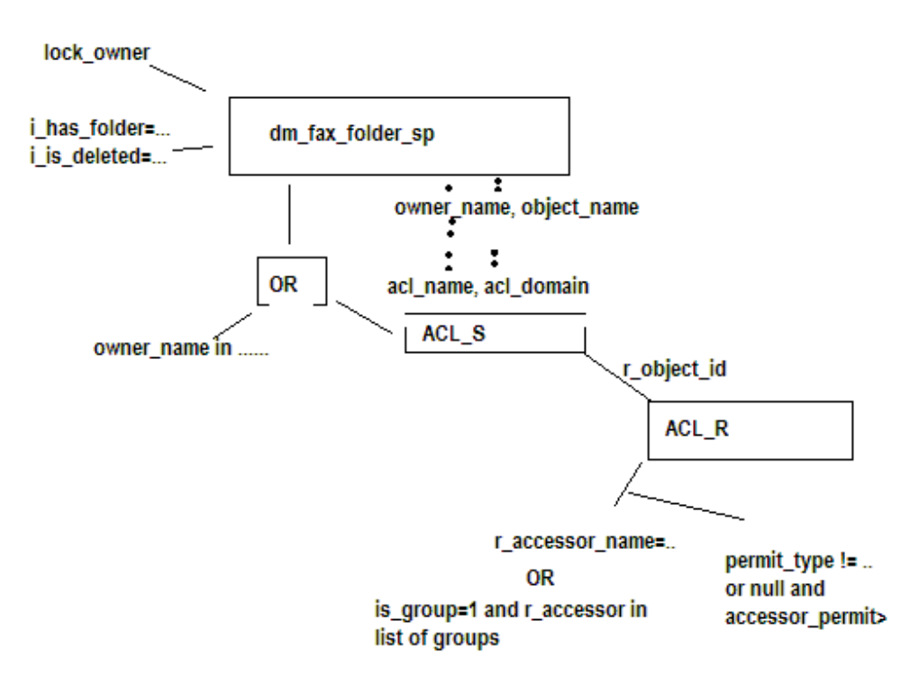

What are the tables involved
What are the joins, and what are the restrictions on the query?
What are the columns being retrieved and how can those columns be retrieved.
Covering indexes
Data pages
Types of joins
Order of joins
# of rows in the tables involved
Cardinality
Indexes on each table
Has statistics run recently

You need to ask – what is the correct way for this query to run and write out your query plan.

It may be that the database is doing as good as possible. Or the plan is not the problem.

Locking can slow queries. Disk I/O. CPU (sorts) . Just because the plan is OK doesn’t mean the performance is OK.

http://support.microsoft.com/?id=224453
SQL Server article

For Oracle tuning - see
http://supportability.documentum.com/rs- bin/RightSite.dll/getcontent/098babbb8002e98b?DMW_OBJECTID=098babbb8002e98b
for more details

Documentum UpdateStats job and Oracle
Our Update Stats script generates a list of all tables owned by the docbase owner and runs analyze table compute statistics on all of them.
This creates a histogram in the database for every row of every relevant table using the default bucket size of 75. In the custom_oracle_stat.sql file - we then adjust some statistics based on our own Oracle tuning experts and performance group - this adjustments are made on the basis of experience using the Documentum server product.
The problem with dbms_stats (Oracle's package) is that it does not look to use a bucket size of 75 (it looks like it uses a smaller bucket size - which spreads the data out less) and it also may use estimate statistics instead of compute statistics. Estimate statistics only samples some rows (either a number or percentage) which is less accurate than gathering information on every row.
If a customer uses a generic statistics package - they simply aren't taking advantage of the knowledge gained and put into place and certain classes of Documentum queries may perform badly.
Regarding the 2 parameters we set
optimizer_index_cost_adj = 5 - this tells the optimizer to adjust the cost of using an index to 5% of that of accessing a table. Our performance group has determined that this setting must be less than 10 for the Documentum Server
optimizer_index_caching = 95 - this tells Oracle that index pages will be cached 95% of the time - it makes it more likely that the Oracle optimizer will choose an index for an access plan.
========

DMCL Trace | Previous Top Next
DMCL Tracing

The simplest way to get a dmcl trace is to edit the dmcl.ini
and add

trace_file = <absolute path to file or directory>
trace_level = 10

For example

trace_file = /tmp/dmcl_trace/trace1.txt
trace_level = 10

If you set trace_file to a directory, make sure the directory exists, and the dmcl will create a new file for each DMCL process.

Dynamic DMCL Tracing

The problem with this method is that it is not dynamic and this is a problem in WDK production environments.

If you have an API command prompt, you can type

trace,c,<level>,<path to trace file>

For example

trace,c,10,c:\temp\trace.txt

This works via both iapi32 and the WDK API Tester.

You may also see: http://softwaresupport.emc.com/WcmprodData/tech%5fpapers%2fWDK%5fDebug%5fTechniques%2epdf
where the method given for DMCL tracing is to navigate to:

http://<host>:<port>/<webapp_virtual_directory>/wdk/dmclTrace.jsp?level=<trace_level>&logfile=<output_file>

Also, see Support Note 44381 DFC,WDK,WebPublisher How can I create a combined dfc and dmcl Trace?

SQL Trace | Previous Top Next
Content Server SQL Tracing

When starting the server add "-osqltrace" to the command line parameters of the documentum.exe (dmserver_v4.exe) or documentum binary

For example, on Unix

./documentum -docbase_name cs53sp1o10g -security acl -init_file /export/plewarf/dctm/dba/config/cs53sp1o10g/server.ini $@ >> $logfile 2>&1 &

will be modified to

./documentum -osqltrace -docbase_name cs53sp1o10g -security acl -init_file /export/plewarf
/dctm/dba/config/cs53sp1o10g/server.ini $@ >> $logfile 2>&1 &

All server queries from all users will be traced and output goes to the docbase log.

Dynamically for all users

apply,c,NULL,SET_OPTIONS,OPTION,S,sqltrace,VALUE,B,T

Dynamically for a single user

apply,c,NULL,SQL_TRACE,LEVEL,I,1

Output goes to session log.

Oracle

From SN 768
http://softwaresupport.emc.com/support/resolutions/dmfrmresolutionview.asp?id=768
Add "sql_trace = TRUE" to init.ora - recompile and restart Oracle.
This will cause all sql statement to be written to ora<pid>.trc files in $ORACLE_BASE/admin/udump. The location is dependent on how the installation was setup. Run select value from v$parameter where name = 'user_dump_dest';
to determine output location.
Session level from an Interactive Documentum Session.
To get trace information at the session level you can either issue the api method 'execsql,c,alter session set sql_trace=TRUE' or the dql statement:
execute exec_sql with query = 'alter session set sql_trace=TRUE'

To trace a specific Oracle session.
trcsess - allows you to trace a specific Oracle session
as does the DBMS_MONITOR package as does. You don't need an
interactive session.

You need to find out which Oracle session corresponds to the Documentum session.
You can use the LIST_SESSIONS/SHOW_SESSIONS apply method and look at db_session_id attribute. Otherwise, you can connect to Oracle and look at the v$session table and take a guess
at your session based on logon_time and os process.

Syntax: trcsess session=96.29472
where the session is in the format SID.SERIAL#

For example -
SQL> ALTER SESSION SET NLS_DATE_FORMAT = 'YYYY-MM-DD HH:MI:SS' ;
SQL> select sid,SERIAL#, process, logon_time from v$session where username = 'AGBOAN';

SID SERIAL# PROCESS LOGON_TIME
---------- ---------- ------------ -------------------
89 7693 1132:3568 2006-03-10 12:01:26
96 29472 1132:2496 2006-03-12 12:34:08
129 19931 1132:1152 2006-03-10 12:00:22
139 31924 1132:3568 2006-03-10 12:01:25
SQL> EXECUTE DBMS_MONITOR.SESSION_TRACE_DISABLE(session_id => 96, serial_num => 29472 );
Output goes to the $ORACLE_BASE/admin/<dbname>/udump is the default location.
For an entire database server
EXECUTE DBMS_MONITOR.DATABASE_TRACE_ENABLE(waits => TRUE, binds=> TRUE, instance_name => 'inst1');

SQL Server

Use SQL Server Profiler Start->Programs->Microsoft SQL Server->Profiler.

For normal situations, use the default template provided by SQL Server - but if you are
tracing for hangs or deadlocks - then add the events RPC:BatchStarting and TSQL:BatchStarting.

Sybase

unknown

DB2

unknown. Try ODBC Tracing.

Last Statement Executed from an Interactive Documentum Session
EXECUTE GET_LAST_SQL

Stack dump of OS Process | Previous Top Next
Windows

Download WinDBG from Microsoft and attach to the process.
Start->Programs->Debugging Tools For Windows->WinDBG
File->Attach to Process
Leave non-invasive unchecked and do not save the workspace information.

One you have attached , you need to create a mini-user dump by typing in the command window .dump /mah <filename.dmp>
(Note the period before the word dump as in dot-dump)

At this time, you can also examine process state by
Add the path to the dll ($DM_HOME/bin) to the Image File path.
Add the path to the pdf ($DM_HOME/bin) to the Symbol File path.
Make sure to check the Reload box while adding the paths or type .reload in the command window.

After that, go to the viewing the View->Threads and View->Call Stack windows.

Remember that if you attach to a process using WinDBG, the process becomes paused.
If you want it to continue, you have to type g on the command window, or press the run button (Debug->Go or F5).

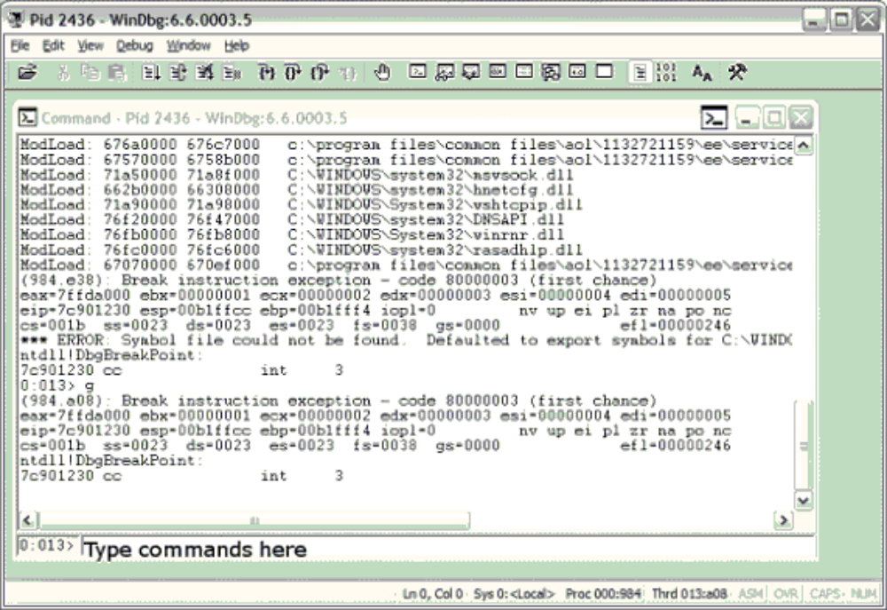
Solaris

pstack
Run pstack <pid> or pstack <corefile>
to get the stack of either a running process, or a core file.

AIX

On AIX 5.2 and above, procstack <pid>
On AIX 5.1 - no known way except attaching a debugger

HP

No known way except attaching a debugger

Linux

pstack <pid>

Java Virtual Machines

On unix systems, issue a kill -3 to generate a javacore.
On Windows, try WinDBG or drwtsn32 -p pid

System call tracing | Previous Top Next
Windows

strace - http://www.bindview.com/Services/RAZOR/Utilities/Windows/strace_readme.cfm

Solaris

truss
For example
truss -o outfile.out -p <pid>
to have truss output go to outfile.out

AIX

truss

HP

tusc
ftp://ftp.cup.hp.com/dist/networking/tools

Linux

strace or ptrace

Network tracing | Previous Top Next
To see ports in use

netstat -a

Tracing network traffic

http://www.ethereal.com



Microsoft SQL Server | Previous Top Next
Determining Database Version

select @@version

from Query analyzer – you should get the results in Text rather than a table.

SQL Tracing, errors, determining what is happening - SQL Server Profiler

After generating a trace, you should save the trace and then open up the trace file you just saved.
Then you can perform filtering operations ,etc on it like only showing the actions of 1 or 2 SPIDS,
etc…

General tracing
Using the standard template is good enough to run normal SQL tracing.

Documentum will issue either SQL Batch statements, these are things like commit, insert, update, and delete, or cursor statements (sp_cursoropen, ….)
These will be generally selects

Hang tracing
In addition to the standard events – add

In events:

RPC Starting
SQL Batch Starting

In data columns

EndTime

The reason we need RPC Starting and SQL Batch Starting is because with a hang, a statement will be started, but will not get completed. If we do not trace starting events, only completed events, we will not know what statement is being run.

Performance tracing

In addition to standard events, one can add reads, writes, duration. In this case, generally we want to see
1.) How expensive is a query?
2.) How often is this query run?

Displaying Locks

sp_lock

or use Enterprise Manager – Management – Current Activity

Adding, Dropping, Modifying Indices (Indexes)

Using Query Analyzer, go to Tools -> Manage Indexes

Changing owners of tables

Sometimes users will have tables which should by owned by dbo, but instead are owned by the actual login name of the docbase owner (dmadmin, tuser1, etc…)

-- Run this as the old_owner
declare @old_owner varchar(32), @new_owner varchar(32)
set @old_owner = 'tuser25'
set @new_owner = 'dbo'
DECLARE @object_name char(128)
declare testcursor CURSOR for
select name from sysobjects where uid = (select uid from sysusers where name = @old_owner)
OPEN testcursor
FETCH NEXT FROM testcursor into @object_name
WHILE @@FETCH_STATUS = 0
BEGIN
PRINT 'Changing ' + @object_name
exec sp_changeobjectowner @object_name, @new_owner
FETCH NEXT FROM testcursor into @object_name
END
close testcursor
deallocate testcursor

DB2 Diagnostics | Previous Top Next
Describing a table

describe table <tablename>
list tables
list tables
SELECT TABSCHEMA, TABNAME
FROM SYSCAT.TABLES

List indexes
from syscat.indexes table

DB2 case insensitive searches
http://www- 128.ibm.com/developerworks/db2/library/techarticle/0203adamache/0203adamache.html

Sybase Diagnostics | Previous Top Next
sp_configure will help configure memory usage, locks, network packet size, etc….

sp_configure

http://manuals.sybase.com/onlinebooks/group- as/asg1250e/ptallbk/@Generic__BookTextView/17268;pt=16103

When your database log is full, if you do sp_who and get log suspend
To truncate the log without making a backup copy:

Solution:
dump tran[saction] database_name with truncate_only

Database Version
select @@version
Information about databases/tables

sp_help <database object>

sp_helpdb <database name>

MySQL Diagnostics | Previous Top Next

From http://sunsite.mff.cuni.cz/MIRRORS/ftp.mysql.com/doc/en/Batch_Commands.html
You can also start your text file with a USE db_name statement. In this case, it is unnecessary to specify the database name on the command line:
shell> mysql < text_file
If you are already running mysql, you can execute a SQL script file using the source command:
mysql> source filename;

http://www.ezdefinition.com/cgi- bin/showcategories.cgi?cid=35&start=40
KILL Syntax KILL thread_id Each connection to mysqld runs in a separate thread. You can see which threads are running with the SHOW PROCESSLIST command and kill a thread with the KILL thread_id command.
SHOW Syntax SHOW provides information about databases, tables, columns, or status information about the server. If the LIKE wild part is used, the wild string can be a string that uses the SQL `%' and `_' wild-card characters.
EXPLAIN Syntax (Get Information About a SELECT) When you precede a SELECT statement with the keyword EXPLAIN, MySQL explains how it would process the SELECT, providing information about how tables are joined and in which order.
Other commands
show processlist - shows what people are doing
\s - (backslash s) - tells server information

Oracle Miscellaneous | Previous Top Next
Example of creating large and small tablespaces
SQL> create tablespace large_tablespace
2 datafile 'f:\oracle\oradata\nagboat\large_tablespace.dbf'
3 size 10M reuse;
Tablespace created.
SQL> alter database
2 datafile 'f:\oracle\oradata\nagboat\large_tablespace.dbf'
3 autoextend on next 512 maxsize unlimited;
Database altered.
SQL> create tablespace small_tablespace
2 datafile 'f:\oracle\oradata\nagboat\small_tablespace.dbf'
3 size 10M reuse;
Tablespace created.
SQL> alter database
2 datafile 'f:\oracle\oradata\nagboat\small_tablespace.dbf'
3 autoextend on next 512 maxsize unlimited;
Database altered.
SQL>SELECT index_name, table_name, tablespace_name from user_indexes;
SELECT table_name, tablespace_name from user_tables;
Determining if an object (such as a view) is invalid.
SELECT OWNER, OBJECT_NAME, OBJECT_TYPE, STATUS FROM DBA_OBJECTS WHERE STATUS = 'INVALID' ORDER BY OWNER, OBJECT_TYPE, OBJECT_NAME;
How to stop and start Oracle
sqlplus /nolog
connect sys/manager as sysdba (or system)
shutdown immediate
startup
lsnrctl
start
How to resize the temp tablespace
http://www.idevelopment.info/data/Oracle/DBA_tips/Tablespaces/TBS_3.shtml
CREATE TEMPORARY TABLESPACE temp2
TEMPFILE 'F:\oracle\oradata\nagboat\temp2_01.dbf' SIZE 5M REUSE
AUTOEXTEND ON NEXT 1M MAXSIZE unlimited
EXTENT MANAGEMENT LOCAL UNIFORM SIZE 1M; ALTER DATABASE DEFAULT TEMPORARY TABLESPACE temp2;
DROP TABLESPACE temp INCLUDING CONTENTS AND DATAFILES;
CREATE TEMPORARY TABLESPACE temp
TEMPFILE 'F:\oracle\oradata\nagboat\temp01.dbf' SIZE 500M REUSE
AUTOEXTEND ON NEXT 100M MAXSIZE unlimited
EXTENT MANAGEMENT LOCAL UNIFORM SIZE 1M;
ALTER DATABASE DEFAULT TEMPORARY TABLESPACE temp;
DROP TABLESPACE temp2 INCLUDING CONTENTS AND DATAFILES;
unix trout
CREATE TEMPORARY TABLESPACE temp2
TEMPFILE '/trout2/oracle92/oradata/trout/temp2_01.dbf' SIZE 5M REUSE
AUTOEXTEND ON NEXT 1M MAXSIZE unlimited
EXTENT MANAGEMENT LOCAL UNIFORM SIZE 1M;
ALTER DATABASE DEFAULT TEMPORARY TABLESPACE temp2;
DROP TABLESPACE temp INCLUDING CONTENTS AND DATAFILES;
CREATE TEMPORARY TABLESPACE temp
TEMPFILE '/trout2/oracle92/oradata/trout/temp_01.dbf' SIZE 500M REUSE
AUTOEXTEND ON NEXT 100M MAXSIZE unlimited
EXTENT MANAGEMENT LOCAL UNIFORM SIZE 1M;
ALTER DATABASE DEFAULT TEMPORARY TABLESPACE temp;
DROP TABLESPACE temp2 INCLUDING CONTENTS AND DATAFILES;
How to drop all tables from an Oracle database.
Example of how to generate an SQL script for Oracle
set head off
spool c:\temp\commands.sql
select 'drop table '||table_name||';' from user_tables;
spool off
@c:\temp\commands.sql
spool c:\temp\commands.sql
select 'drop view '||view_name||';' from user_views;
spool off
@c:\temp\commands.sql
commit;
Displaying a full time date in SQLPlus
ALTER SESSION SET NLS_DATE_FORMAT = 'YYYY-MM-DD HH:MI:SS' ;
Oracle version information
select version from product_component_version where product like 'O%';
select * from v$version;
Dropping a tablespace DROP Tablespace <name> including contents;
http://www.iselfschooling.com/mc4articles/mc4recovery.htm
problems with datafiles, offline, etc.
----
Updating statistics
analyze table <tablename> compute statistics;

Various
select sid, sql_text
from v$session s, v$sql q
where sid in (254,270)
and (
q.sql_id = s.sql_id or
q.sql_id = s.prev_sql_id);
select v.sid, object_name, subobject_name , object_id from v$lock v, user_objects u where v.id1 = u.object_id;
---------------------
select wait_class_id, wait_class,
total_waits, time_waited
from v$session_wait_class
where sid = *****;

Locks Held | Previous Top Next
Oracle
select * from v$lock
Find lock type of TX and see the corresponding TS, look at the row containing TS
and note the object_id. The object_id is the id of the object being locked, you can determine the name of the object
object_id in select * from all_objects where object_id = (the id in the TS column)
v$session maps SID to user.

Sybase
sp_who, sp_lock, and sp_familylock
SELECT spid
FROM master..sysprocesses
WHERE blocked > 0
select object_name(<object id>) to determine the name of the object that is locked.

DB2
db2 get snapshot for locks on <dbname>

or if you want detailed information about one connection:

db2 get snapshot for locks for application agentid <id>
or
db2 get snapshot for locks for application applid <applid>

MySQL

http://mtop.sourceforge.net/mtop.html

SQL Server
INF: How to Monitor SQL Server 2000 Blocking
http://support.microsoft.com/default.aspx?scid=kb;en-us;271509

This gives the code for sp_blocker

INF: Understanding and Resolving SQL Server 7.0 or 2000 Blocking Problems
http://support.microsoft.com/default.aspx?scid=http://support.microsoft.com:80/support/kb/articles/Q224/4/53.ASP&NoWebContent=1

On SQL Server - you should get lock information in 2 ways.

1.) Run sp_lock in Query Analyzer
2.) Use Enterprise Manager to get a graphical picture of locks.
Start->Programs->SQL Server->Enterprise Manager-> (your server/database)->Current Activity.
Refresh the current activitiy and look at the session and locks held.

Use the sp_blocker script at
http://support.microsoft.com/default.aspx?scid=kb;en-us;271509

Get a screenshot like the following for each session that is in the locking chain.

Each Process in “Locks/Process Id “
and
Each Object in “Locks/Object”

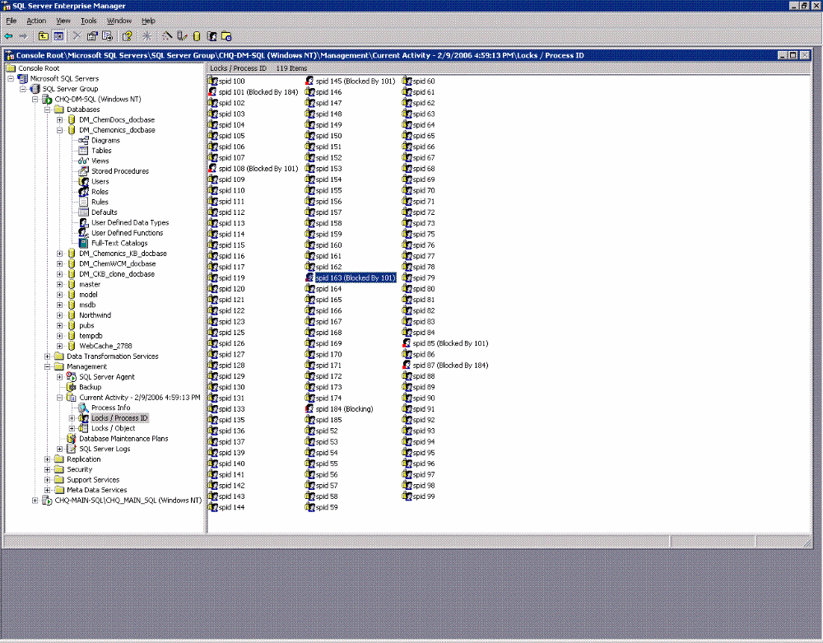

sp_lock

Sample output:

spid dbid ObjId IndId Type Resource Mode Status
------ ------ ----------- ------ ---- ---------------- -------- ------
52 4 0 0 DB S GRANT
53 4 0 0 DB S GRANT
54 12 0 0 DB S GRANT
55 12 0 0 DB S GRANT
56 12 0 0 DB S GRANT
57 7 0 0 DB S GRANT
59 12 0 0 DB S GRANT
60 8 0 0 DB S GRANT

Current Queries | Previous Top Next
Oracle
Display the current cursor being executed by a session.
select a.sid, a.username, b.sql_text
from v$session a, v$open_cursor b
where a.saddr = b.saddr;
Display the entire SQL statement being executed by all sessions.
select a.sid, a.username, b.sql_text
from v$session a, v$sqltext b
where a.sql_address = b.address
and a.sql_hash_value = b.hash_value
order by a.sid, a.username, b.piece;
Display each cursor of the shared cursor cache, including the times executed and loaded into the cache.
select sql_text, version_count, executions, loads from v$sqlarea;
Display detail information about a session, including the operating system username and process, and terminal.
select sid, username, program, osuser, process, machine, terminal, type from v$session;
Display detailed statistics per session to determine a session’s resource usage.
select a.sid, a.username, b.name, c.value
from v$session a, v$statname b, v$sesstat c
where a.sid = c.sid
and b.statistic# = c.statistic#
and a.username = upper(‘&username’)
order by a.sid, a.username, b.name;
Determine the objects that are being accessed by each session.
select a.sid, a.username, b.owner, b.object, b.ob_typ
from v$session a, v$access b
where a.sid = b.sid;
Display the processes for each session. If the process is a background process, then the operating system and identifier are retrieved from the process table.
select a.sid, decode(b.background,1,b.program,a.username)
"user", b.pid,
decode (b.background,1,b.spid,a.audsid) "os id"
from v$session a, v$process b
where a.paddr = b.addr;
The following query returns a list of users that are locked at the current time:
select a.username, a.sid, a.serial#, b.id1, c.sql_textfrom v$session a, v$lock b, v$sqltext cwhere a.lockwait = b.kaddrand a.sql_address = c.address
and a.sql_hash_value = c.hash_value;
Current SQL Statements
select sesion.sid, sesion.username,
optimizer_mode, hash_value,
address, cpu_time,
elapsed_time, sql_text
from v$sqlarea sqlarea, v$session sesion
where sesion.sql_hash_value = sqlarea.hash_value
and sesion.sql_address = sqlarea.address
and sesion.username is not null
Another query for SQL Statements
select sesion.sid,
sql_text
from v$sqltext sqltext, v$session sesion
where sesion.sql_hash_value = sqltext.hash_value
and sesion.sql_address = sqltext.address
and sesion.username is not null
order by sqltext.piece
Oracle 10G query for blocked sessions
select sid, username, event, blocking_session,
seconds_in_wait, wait_time
from v$session where state in ('WAITING')
and wait_class != 'Idle';
Oracle 10g Script for Waiting sessionsCut and paste the following into SQLPlus
Source: http://www.oracle.com/technology/oramag/code/tips2004/062104.html
========= BEGIN CUT ===========set serverout on size 999999
declare
begin
dbms_output.put_line(' ');
dbms_output.put_line('************* Start report for WAITING sessions with current SQL ***************');
for x in (select vs.inst_id, vs.sid || ',' || vs.serial# sidser, vs.sql_address, vs.sql_hash_value,
vs.last_call_et, vsw.seconds_in_wait, vsw.event, vsw.state
from gv$session_wait vsw, gv$session vs
where vsw.sid = vs.sid and vsw.inst_id = vs.inst_id
and vs.type <> 'BACKGROUND' and vsw.event NOT IN ('rdbms ipc message'
,'smon timer' ,'pmon timer' ,'SQL*Net message from client' ,
'lock manager wait for remote message'
,'ges remote message' ,'gcs remote message'
,'gcs for action' ,'client message' ,'pipe get' ,'Null event'
,'PX Idle Wait' ,'single-task message'
,'PX Deq: Execution Msg' ,'KXFQ: kxfqdeq - normal deqeue'
,'listen endpoint status' ,'slave wait' ,'wakeup time manager'))
loop
begin
dbms_output.put_line('Event WaitState InstID SidSerial LastCallEt SecondsInWait');
dbms_output.put_line('************************* ******************** ****** *********** ********** *************');
dbms_output.put_line(rpad(x.event,25) ||' '|| rpad(x.state,20) ||' '|| lpad(x.inst_id,6) ||' '|| lpad(x.sidser,11) ||'
'|| lpad(x.last_call_et,10) ||' '|| lpad(x.seconds_in_wait,13));
dbms_output.put_line(' SQLText ');
dbms_output.put_line('****************************************************************');
for y in (select sql_text
from gv$sqltext where address = x.sql_address
and hash_value = x.sql_hash_value
and inst_id = x.inst_id
order by piece)
loop
dbms_output.put_line(y.sql_text);
end loop;
end;
end loop;
dbms_output.put_line('************** End re! port for sessions waiting with current SQL ****************');
dbms_output.put_line(' ');
end;
/
DB2
select * from table(SNAPSHOT_DYN_SQL(' ',-1)) as dysql where 1 = 2
DB2 get snapshot for application agentid handel
http://database.ittoolbox.com/documents/popular-q-and-a/current-query-running-on-db2- database-4741
db2 "SELECT * FROM TABLE(SNAPSHOT_appl_info('sample',-1)) AS SNAP"|more
- the applications
db2 list applications show detail
output from list applications
“Status”: A value of “Lock-wait” means the application is blocked by a lock held by a
different application. Don’t be confused by a value of “UOW Waiting”: it means that the
application (unit of work) is in progress, not blocked on a lock, but is just not doing any work
at the moment. However, when a lock conflict does occur, an application holding locks that
others are blocked on will usually have a status of “UOW Waiting”, so that status is not
necessarily an innocuous one.
“Status Change Time”: This is of particular interest for an application with Lock-wait
status: it shows when the lock wait began. Note that the UOW monitor switch must be on for
this time to be reported.
“Appl. Handle”: The handle is an integer value that serves two main purposes:
It allows the LIST APPLICATIONS information to be correlated with the output of
snapshot and event monitors discussed below.
It provides the value that you can use in the FORCE APPLICATION command to force
an application that’s holding locks which are causing contention problems.
DB2^{(R)} Query Patroller
db2pd
SQL Server
Use Enterprise Manager to examine the sessions and double click on the session. Otherwise
in Query Analyzer, type DBCC INPUTBUFFER (<spid>)
or
DECLARE @Handle binary(20)
SELECT @Handle = sql_handle FROM sysprocesses WHERE spid = 52
SELECT * FROM ::fn_get_sql(@Handle)
Sybase
Should be the same as SQL Server
MySQL
http://mtop.sourceforge.net/mtop.html

Deadlock tracing | Previous Top Next
SQL Server

dbcc traceon turns on internal tracing flags. 1204/1205 are deadlock traces, and 3605
tells the server to output messages to the server log.

dbcc traceon(1204, 1205, 3605)

Use the sp_blocker script at
http://support.microsoft.com/default.aspx?scid=kb;en-us;271509

Sybase

dbcc traceon(1204, 1205, 3605)

DB2

http://www3.software.ibm.com/ibmdl/pub/software/dw/dm/db2/0310wilkins/0310wilkins.pdf

You need to create a deadlock monitor on DB2 and then recreate the locking situation.
CREATE EVENT MONITOR [Name]
FOR [DATABASE |
BUFFERPOOLS |
TABLESPACES |
TABLES |
DEADLOCKS < WITH DETAIL > |
CONNECTIONS < WHERE [EventCondition] > |
STATEMENTS < WHERE [EventCondition] > |
TRANSACTIONS < WHERE
[EventCondition] > , ...]
WRITE TO [TABLE [GroupName] (TABLE
[TableName]) |
PIPE [PipeName] |
FILE [DirectoryName]]
[MANUALSTART | AUTOSTART]
db2 connect to sample
db2 "create event monitor dlmon for tables, deadlocks with details
write to file 'c:\dlmon'"
mkdir c:\dlmon
db2 "set event monitor dlmon state 1"

Queryplans | Previous Top
DB2
DB2expln - DB2 SQL Explain Tool
Here is an example of the db2 command line tool:
db2expln -d DB2_DB1 -u tuser1 n0lif3 -o temp3.out -statement "select all d
m_sysobject.r_is_virtual_doc, dm_sysobject.r_link_cnt, dm_sysobject.r_object_id,
dm_sysobject.object_name, dm_sysobject.i_is_reference, dm_sysobject.r_content_s
ize from dm_sysobject_sp dm_sysobject where (lower(dm_sysobject.object_name) lik
e 'on_ 4%') and (dm_sysobject.i_has_folder = 1 and dm_sysobject.i_is_deleted = 0
) for read only optimize for 20 rows"
db2exfmt and Visual Explan (invoked from the DB2 command center)can provide better graphical explanations

Oracle

For a single statement - you can run EXPLAIN PLAN or 'set autotrace on'
Run the SQL Script $ORACLE_HOME/rdbms/admin/utlxplan.sql to create the plan table.
From SQLPlus, run
EXPLAIN PLAN SET STATEMENT_ID = 'st1' FOR SELECT last_name FROM employees;
SELECT PLAN_TABLE_OUTPUT FROM TABLE(DBMS_XPLAN.DISPLAY());
For example:
SQL> set wrap off
SQL> set head off;
SQL> EXPLAIN PLAN FOR select user_name from dm_user_s;
Explained.
SQL> SELECT PLAN_TABLE_OUTPUT FROM TABLE(DBMS_XPLAN.DISPLAY());
Plan hash value: 4057744804
--------------------------------------------------------------------------------
| Id | Operation | Name | Rows | Bytes | Cost (%CPU)| Tim
--------------------------------------------------------------------------------
| 0 | SELECT STATEMENT | | 29 | 493 | 1 (0)| 00:
| 1 | INDEX FULL SCAN | D_1F000DE480000017 | 29 | 493 | 1 (0)| 00:
--------------------------------------------------------------------------------
8 rows selected.

set autotrace on give a bit more information.

For a particular session or entire database instance - get the SQL trace .trc file from Oracle
and run tkprof. See the SQL Trace section for instructions on enabling tracing.
tkprof - this will format the sql trace file from Oracle to make them easier to understand
tkprof filename1 filename2 [waits=yes|no] [sort=option] [print=n] [aggregate=yes|no] [insert=filename3] [sys=yes|no] [table=schema.table] [explain=user/password] [record=filename4] [width=n]

This is generally what you need
tkprof input.trc output.trc sys=no explain=tuser1/n0lif3

Sql Server

Use query analyzer

You can also have SQL Server give suggestions on improving performance with the

Sybase

From isql run
set statistics io, time on <== Turns on statistics
set showplan on <=== Turns on Query plans
For more advanced tuning, use dbcc trace flags 302 and 310. Here is what the Sybase manual says "http://sybooks.sybase.com/nav/detail.do?docset=783"
Invoking the dbcc trace facility
To start the dbcc traceon(302) trace facility, execute the following command from an isql batch, followed by the query or stored procedure that you want to examine:
dbcc traceon(3604, 302)
This is what the trace flags mean:
Trace flag | Explanation
3604 | Directs trace output to the client, rather than to the error log.
302 | Prints trace information on index selection.
To turn off the output, use:
dbcc traceoff(3604, 302)
dbcc traceon(302) is often used in conjunction with dbcc traceon(310), which provides more detail on the optimizer's join order decisions and final cost estimates. dbcc traceon(310) also prints a "Final plan" block at the end of query optimization. To enable this trace option also, use:
dbcc traceon(3604, 302, 310)

